User interface specification

Graphical User Interface

Graphical views:

Start Window | In Game Window
When application starts running the main menu and empty stage displayed. Stage represented by 10x10 grid of fields. Each grid element has 60x60 pixels resolution. Application of the window is not resizable. In order to start playing the player must start the game from the main menu.  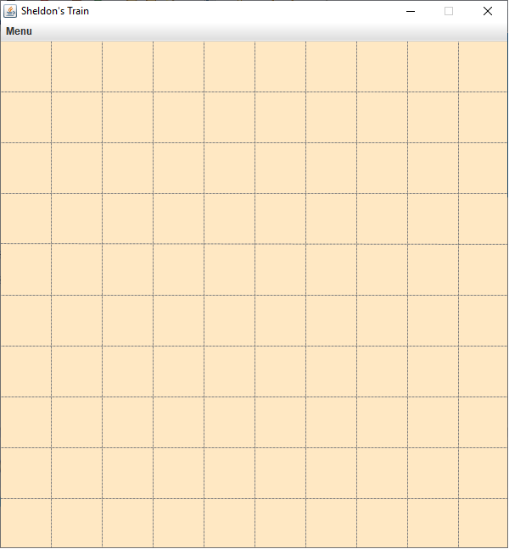 | When the player is ready, he will start the game and trains will follow the course of the rail system. It is possible to modify the switches or tunnels after the trains have started moving, by pressing on the appropriate field with mouse. Trains move with the same constant speed and all of them have some number of railroad cars attached to the engine.  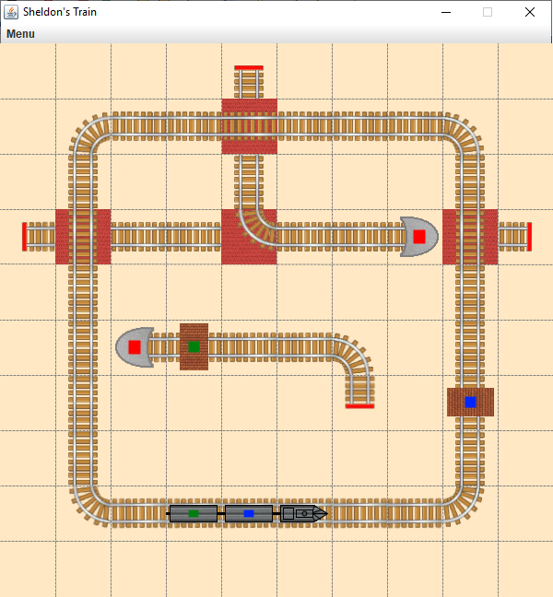

The view elements:

Main menu | Stage Completed Window | Game Over Window
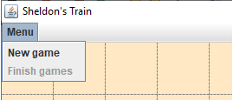  The main menu of application contains only 2 options: „New game” and „Finish games”. | 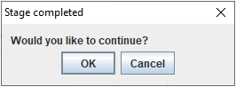  Application notifies the player that stage is cleared successfully using simple confirmation dialog window. | 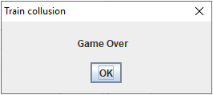  Application notifies the player that trains collide the game is lost using simple dialog window.

The graphical elements:

Object type | Graphical representation
DeadEnd | 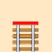  DeadEnd is the type of Field that has only one entrance without any exit. If the engine enters the DeadEnd it loses the game.
Engine | 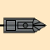  Engine is a leading part of the rail system. It doesn’t have color or passengers on its own. Whenever the train moves forward on the rail, engine is the first part of the train that meets the new object: rail, station, switch or a tunnel.
PassengerCar | 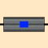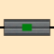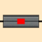  blue green orange pink red yellow empty  PassengerCar is a part of the train. It has a color and may or may not contain passengers. By itself, a car performs the discharge of the passengers, which is its main responsibility. When a train meets the station, a car must determine if the color of the station matches its’ own color. If so, it will discharge the passengers (if not already empty).
RailRoad | 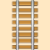  straight bend  RailRoad is the simplest type of the part of rail system. It has two entrances and can only hold one car at a time.
Station | 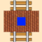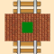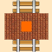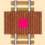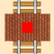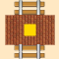  blue green orange pink red yellow  Station is the part of the rail system. Every station has an associated color. If the train car meets the station that has corresponding color, passengers from the car leave the train and are accepted by the station.
Switch | 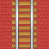  straight bend  Switches are present at the interjections of the rails. It defines how the intersecting rails relate to each other. Player can change the direction of the switch.
Tunnel |   activated deactivated  Tunnel can create a new path for the train to take. When a train enters a tunnel, it knows that it should follow a path which is topologically different from the visible (surface) railroad and emerge on the other side of the tunnel.

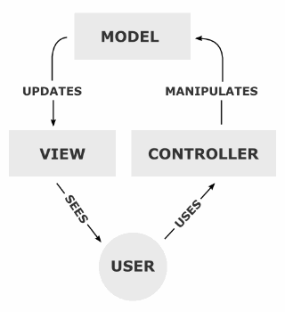
Architecture of the graphical system

Principles of the GUI
The application is Model-View-Controller architecture, where:
Model – application logic;
View – presentation;
Controller – interaction: communication with the user.

The Model represented by the classes delivered previously (classes of the prototype).
All types of objects that have graphical representation on the screen to user (mentioned in chapter 11.1 Graphical User Interface) have a „graphical class” (name convention: G[object class name]) which extends Drawable abstract class.
The View class stored references to all Drawable objects and redraw them when change (time elapse) occurred.
The Controller class subscribes to the appropriate events at the beginning of the program, after the creation of Model and View objects. It then responds to events that are predominantly mouse button clicks.

The application behavior implements push-based Model and has following steps:
The Controller handles the events
The Controller notifies the Model
The Model notifies the View about the change (time elapsed).
The View queries the state of the Model and refreshes user interfaces

The application initialization is following:
The Main application creates the Model;
The Main application creates the View;
The View creates the Controller;
The View attaches itself to the Model.

GUI Structure diagram
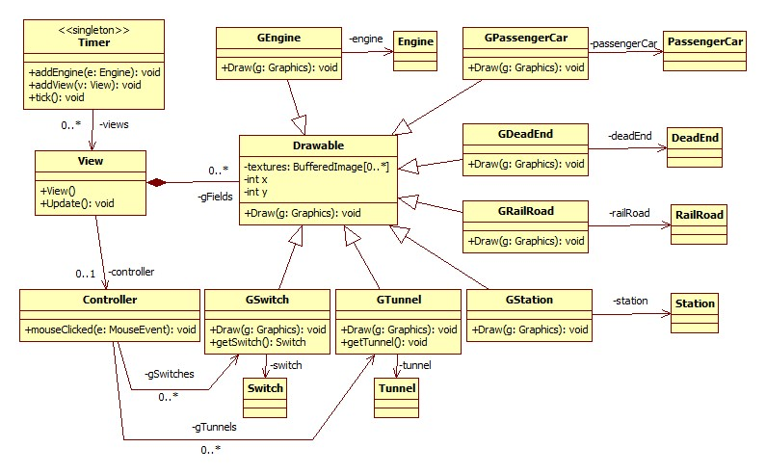
Remark: not all constructors, getters, setters are shown in order to improve readability.

GUI Classes

11.3.1 View
Responsibility
The View class stores references to all Drawable objects and redraws them when change occurs. It is responsible for keeping track of all the graphical objects in the game (stage). It crates all the graphical elements, initializes them and calls the draw method for all the game objects that have a graphical representation.
Superclasses
This class has no superclass.
Interfaces
This class doesn’t implement any interface.
Attributes
ArrayList<IDrawable> gFields - this attribute is a reference to ArrayList of the graphical objects of fields that the stage is holding.
Controller controller - this attribute is reference to View controller, which is listening to the mouse related events.
Methods
View() - this method is a constructor of the class.
void Update() - this method calls the Draw method on every object referenced in gFields attribute.

11.3.2 Controller
Responsibility
The Controller class subscribes to the appropriate events at the beginning of the program, after the creation of Model and View objects. It then responds to events that are predominantly mouse button clicks.
Superclasses
This class has no superclass.
Interfaces
This class implements MouseListener interface
Attributes
ArrayList<GSwitch> gSwitches - this attribute is reference to ArrayList of the graphical objects of switches that the stage is holding.
ArrayList<GTunnel> gTunnels - attribute is reference to ArrayList of the graphical objects of tunnels that the stage is holding.
Methods
void Controller() - this method is constructor of the class
void setGSwitches (ArrayList<GSwitch> gSwitches) - this method is setter of gSwitches attribute
void setGTunnelels (ArrayList<GTunnel> gTunnels) - this method is setter of gTunnelsattribute
void mouseClicked (MouseEvent e) - this method checks the position(coordinates) the mouse clicked on. If mouse clicked on switch, controller calls changeDirection method. If mouse clicked on tunnel, controller calls activate/deactivate methods (depending on current state of the Tunnel).

11.3.3 Drawable
Responsibility
Drawable is an abstract super class for all the game objects that have the graphical representation in the game. It contains the current coordinates for the graphical object and the corresponding images.
Superclasses
This class has no superclass.
Interfaces
This class doesn’t implement any interface.
Attributes
ArrayList<BufferedImage> textures - this attribute contains all the images that might be needed to draw the object in the stage.
int x - this attribute is a horizontal coordinate of the object image;
int y - this attribute is a vertical coordinate of the object image;
Methods
void Draw(Graphics g) - this method draws image on the stage using current texture image and coordinates. Method calls Draw method on Car of current field.

11.3.4 GDeadEnd
Responsibility
Stores the reference to the DeadEnd object, its’ coordinates on the map and the images needed to create a graphical representation. Is responsible for drawing the object, with given coordinates and images.
Superclasses
Drawable
Interfaces
This class doesn’t implement any interface.
Attributes
DeadEnd deadEnd - this attribute is reference to the corresponding DeadEnd object.
Methods
void DeadEnd (DeadEnd d) - this method is constructor of the class.
void Draw(Graphics g) - this method draws image on the stage using current texture image and coordinates. Method calls Draw method on Car of current field.

11.3.5 GRailRoad
Responsibility
Stores the reference to the RailRoad object, its’ coordinates on the map and the images needed to create a graphical representation. Is responsible for drawing the object, with given coordinates and images.
Superclasses
Drawable
Interfaces
This class doesn’t implement any interface.
Attributes
RailRoad railroad - this attribute is reference to the corresponding RailRoad object.
Methods
void GRailRoad (RailRoad r) - this method is constructor of the class.
void Draw(Graphics g) - this method draws image on the stage using current texture image and coordinates. Method calls Draw method on Car of current field.

11.3.6 GSwitch
Responsibility
Stores the reference to the Switch object, its’ coordinates on the map and the images needed to create a graphical representation. Is responsible for drawing the object, with given coordinates and images.
Superclasses
Drawable
Interfaces
This class doesn’t implement any interface.
Attributes
Switch switch- this attribute is reference to the corresponding Switch object.
Methods
void GSwitch (Switch s) - this method is constructor of the class.
void Draw(Graphics g) - this method draws image on the stage using current texture image and coordinates. Method calls Draw method on Car of current field.
Switch getSwitch() - this method is getter of switch attribute.

11.3.7 GTunnel
Responsibility
Stores the reference to the Tunnel object, its’ coordinates on the map and the images needed to create a graphical representation. Is responsible for drawing the object, with given coordinates and images.
Superclasses
Drawable
Interfaces
This class doesn’t implement any interface.
Attributes
Tunnel tunnel- this attribute is reference to the corresponding Tunnel object.
Methods
void GTunnel (Tunnel t) - this method is constructor of the class.
void Draw(Graphics g) - this method draws image on the stage using current texture image and coordinates. Method calls Draw method on Car of current field.
Tunnel getTunnel() - this method is getter of tunnel attribute.

11.3.8 GStation
Responsibility
Stores the reference to the Station object, its’ coordinates on the map and the images needed to create a graphical representation. Is responsible for drawing the object, with given coordinates and images.
Superclasses
Drawable
Interfaces
This class doesn’t implement any interface.
Attributes
Station station - this attribute is reference to the corresponding Station object.
Methods
void GStation (Station s) - this method is constructor of the class.
void Draw(Graphics g) - this method draws image on the stage using current texture image and coordinates. Method calls Draw method on Car of current field.

11.3.9 GEngine
Responsibility
Stores the reference to the Engine object, its’ coordinates on the map and the images needed to create a graphical representation. Is responsible for drawing the object, with given coordinates and images.
Superclasses
Drawable
Interfaces
This class doesn’t implement any interface.
Attributes
Engine engine- this attribute is reference to the corresponding Engine object.
Methods
void GEngine (Engine e) - this method is constructor of the class.
void Draw(Graphics g) - this method draws image on the stage using current texture image and coordinates. Method calls Draw method on Car of current field.
11.3.10 GPassengerCar
Responsibility
Stores the reference to the PassengerCar object, its’ coordinates on the map and the images needed to create a graphical representation. Is responsible for drawing the object, with given coordinates and images.
Superclasses
Drawable
Interfaces
This class doesn’t implement any interface.
Attributes
PassengerCar passengerCar - this attribute is reference to the corresponding PassengerCar object.
Methods
void GPassengerCar (PassengerCar pc) - this method is constructor of the class.
void Draw(Graphics g) - this method draws image on the stage using current texture image and coordinates. Method calls Draw method on Car of current field.
11.3.11 Timer
Responsibility
The main timer of the game. On Every tick every engine makes a move and all views make an update.
Superclasses
This class has no superclass.
Interfaces
This class doesn’t implement any interface.
Attributes
ArrayList<Engine > engines- this attribute is a reference to ArrayList of the engines that the stage is holding.
ArrayList<View > views - this attribute is a reference to ArrayList of the views.
Methods
Timer() - this method is constructor of the class.
void addEngine(Engine e) - this method adds engine to the engines array.
void addEngine(View v) - this method adds view to the engines array.
void tick() - this method make fires moves on every engine in the engines collection and calls update on all of the views.

Dynamic connection between the model and the GUI

11.4.1. Initialization of MVC architecture

The application initialization is following:
The Main application creates the Model;
The Main application creates the View;
The View creates the Controller;
The View attaches itself to the Model.

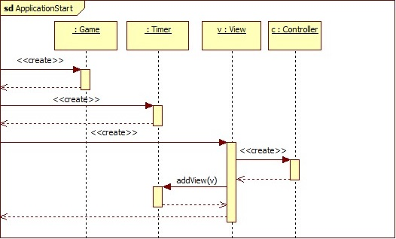

11.4.2 Controller – Model Interaction

The Controller class subscribes to the appropriate events at the beginning of the program, after the creation of Model and View objects. It then responds to events that are predominantly mouse button clicks.
There are 2 types of the objects that can be modified after interaction with user:
- Switch. Controller – Model (Switch) Interaction

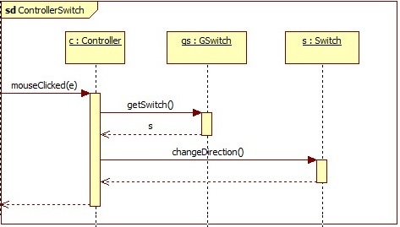
- Tunnel. Controller – Model (Tunnel) Interaction

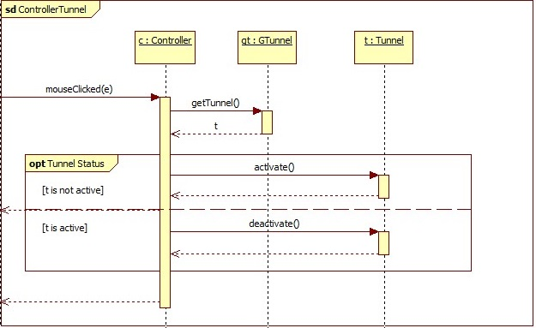

11.4.3 Model – View interaction

The Model notifies the View about the change (time elapsed) by calling Update method. Update method calls the Draw method on every object referenced in gFields attribute.

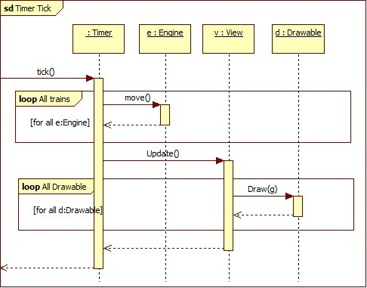

If the field has a Car on it, Draw method calls Draw method on Car of current field.

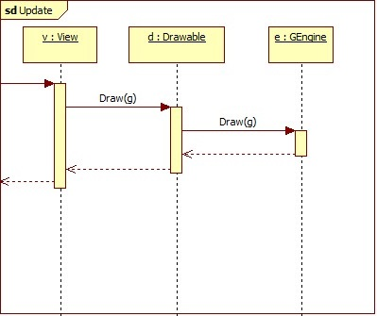

Protocol

Start (date & time) | Duration (hours) | Performer(s) name | Activity description
23.04.2019 10:00 | 2 hours | Irakli Vashakidze, Mikheil Tabidze, Shota Osepashvili, Yasir M. Suliman A., Yekaterina Ussacheva | Consultation with course lecturer Dr. Katalin Balla
24.04.2019 12:00 | 1 hour | Irakli Vashakidze, Mikheil Tabidze, Shota Osepashvili, Yasir M. Suliman A., Yekaterina Ussacheva | Meeting. Decisions  Irakli Vashakidze is responsible for the preparing 11.1 Graphical User Interface, the deadline is 28.04.2019  Mikheil Tabidze is responsible for the preparing 11.2 Architecture of the graphical system, the deadline is 28.04.2019  Shota Osepashvili is responsible for the preparing 11.3 GUI Classes, the deadline is 28.04.2019  Yasir M. Suliman A. is responsible for the preparing 11.4 Dynamic connection between the model and the GUI part 1, the deadline is 28.03.2019  Yekaterina Ussacheva is responsible for the preparing 11.4 Dynamic connection between the model and the GUI Part 2, the deadline is 28.03.2019
27.04.2019 10:00 | 4 hours | Irakli Vashakidze | Preparing 11.1 Graphical User Interface
27.04.2019 10:00 | 4.5 hours | Mikheil Tabidze | Preparing 11.2 Architecture of the graphical system
27.04.2019 10:00 | 4 hours | Shota Osepashvili | Preparing 11.3 GUI Classes
27.04.2019 12:00 | 3 hours | Yasir M. Suliman A. | Preparing 11.4 Dynamic connection between the model and the GUI Part 1
27.04.2019 14:00 | 3 hours | Yekaterina Ussacheva | Preparing 11.4 Dynamic connection between the model and the GUI Part 2
29. 04.2019  10:00 | 0.5 hour | Irakli Vashakidze, Mikheil Tabidze, Shota Osepashvili, Yasir M. Suliman A., Yekaterina Ussacheva | Meeting. Submission of 11. User interface specification

